**Lab 3**

**1. Explore $_SERVER PHP super global variable.**

$_SERVER is a PHP super global variable which holds information about headers, paths, and script locations.

**Code:**

<?php

echo $_SERVER['PHP_SELF'];

echo "<br>";

echo $_SERVER['SERVER_NAME'];

echo "<br>";

echo $_SERVER['HTTP_HOST'];

echo "<br>";

echo $_SERVER['HTTP_REFERER'];

echo "<br>";

echo $_SERVER['HTTP_USER_AGENT'];

echo "<br>";

echo $_SERVER['SCRIPT_NAME'];

echo "<br>";

?>

**Output:**

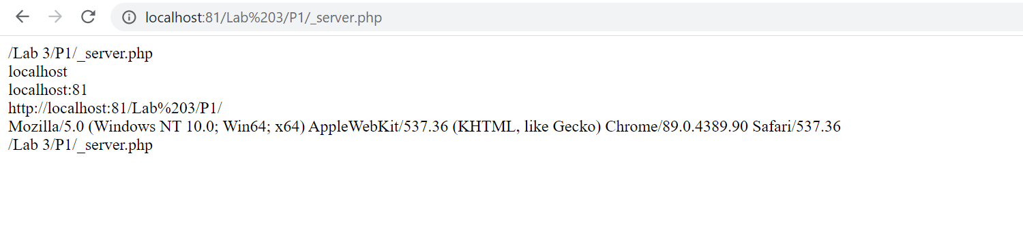**2. Explore the header function in PHP.**

The header() function sends a raw HTTP header to a client.

**It is important to notice that the header() function must be called before any actual output is sent!**

**3. Create a Home page named index.php.**

**Code:**

<form method="POST" action="test.php">

<table border="1">

<tr>

<td>Username:</td>

<td><input type="text" name=""></td>

</tr>

<tr>

<td>Password</td>

<td><input type="Password:" name=""></td>

</tr>

<tr>

<td><input type="submit" name="login" value="login"></td>

<td><input type="reset" name=""></td>

</tr>

<tr>

<td>New user?&nbsp<a href="">click here</a></td>

</tr>

</table>

</form>

**Output:**

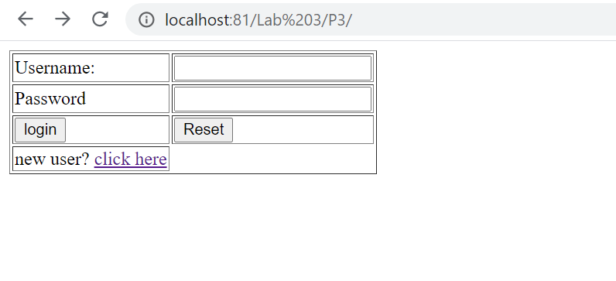

**4. Create a registration form for a new user named registration.php**

**Code:**

**registration.php:**

<form method="POST" action="notification.php" name="myForm" required>

<table border="1">

<tr>

<td colspan="3">*Required field</td>

</tr>

<tr>

<td colspan="1">*Username:</td>

<td colspan="2"><input type="text" maxlength="11" minlength="1" name="uname"></td>

</tr>

<tr>

<td colspan="1">*Email Address:</td>

<td colspan="2"><input type="text" name="email"></td>

</tr>

<tr>

<td colspan="1">*Password:</td>

<td colspan="2"><input type="Password" name="pass" minlength="6" maxlength="10"></td>

</tr>

<tr>

<td colspan="1">*Confirm Password:</td>

<td colspan="2"><input type="Password" name="" minlength="6" maxlength="10"></td>

</tr>

<tr>

<td colspan="1">*Gender:</td>

<td colspan="2"><input type="radio" name="gen" value="Female">Female &nbsp<input type="radio" value="Male" name="gen">Male</td>

</tr>

<tr>

<td colspan="3">Achievements:</td>

</tr>

<tr>

<td colspan="3"><textarea name="achievements" rows="10" cols="40"></textarea></td>

</tr>

<tr>

<td colspan="1"><input type="submit" name=""></td>

<td colspan="1"><input type="reset" name=""></td>

<td colspan="1"><a href="../P3/">Home</a></td>

</tr>

</table>

</form>

**notification.php:**

You are registered

<?php

if(!empty($_POST['uname']) && !empty($_POST['pass'])){

echo "<table border='1 solid'>";

echo "<tr>";

echo "<td>Username:</td>";

echo "<td>" . $_POST['uname'] . "</td>";

echo "</tr>";

echo "<tr>";

echo "<td>Password:</td>";

echo "<td>" . $_POST['pass'] . "</td>";

echo "</tr>";

echo "<tr>";

echo "<td>Email:</td>";

echo "<td>" . $_POST['email'] . "</td>";

echo "</tr>";

echo "<tr>";

echo "<td>Gender:</td>";

echo "<td>" . $_POST['gen'] . "</td>";

echo "</tr>";

echo "<tr>";

echo "<td>Achievements:</td>";

echo "<td>" . $_POST['achievements'] . "</td>";

echo "</tr>";

echo "<tr>";

echo "<td><a href='../P3/''>Return Home</a></td>";

echo "</tr>";

echo "</table>";

}else {

echo "Username or password empty";

}

?>

**Output:**

**When data is filled**

**1.**

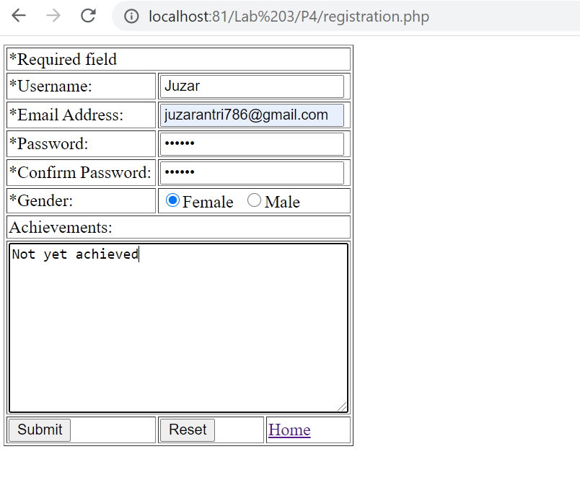

**2.**

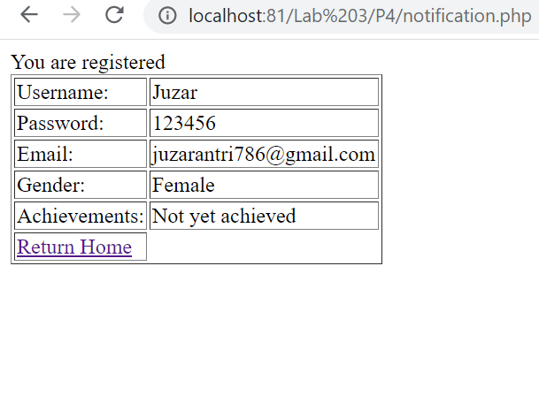

**When data is empty**

**1.**

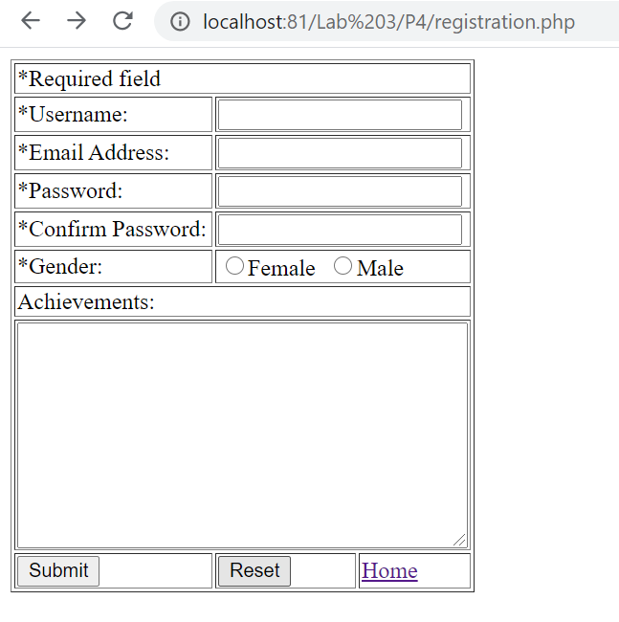

**2.**

